Engineering Diagrams & Flowcharts

Lock Unlock Screen Inter-App Orchestration

Diagram 1: Multi-App Lock/Unlock Priority Arbitration Flow
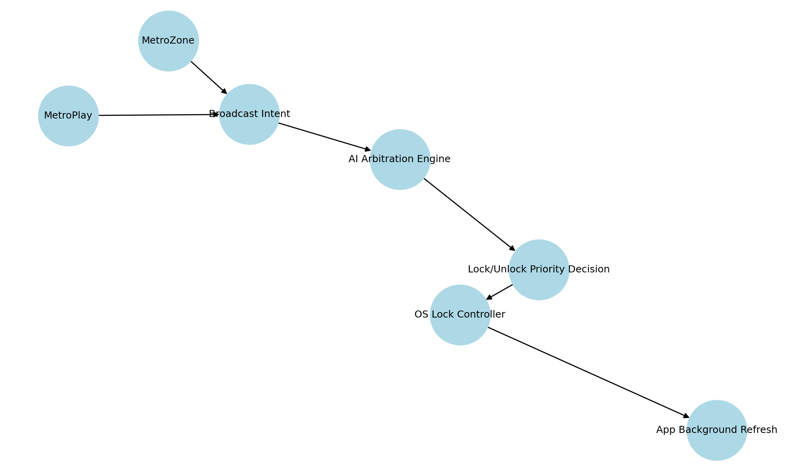

Diagram 2: Broadcast Intent Signal Flow Between Apps
